**Timecheck Software Installation - Guide**

**Before starting the installation of timecheck software, please ensure IIS, SQL Server 2008 / above, .Net Framework 4.0 and above, Crystal reports 13.0.2000.0 are installed into current machine.**

**How to check IIS Installed into current machine:**

To ensure that IIS is installed on your local system. You may open any browser which you want and then in the address bar of that browser, just type **“http://localhost”**.

You will see a web page as shown below.

[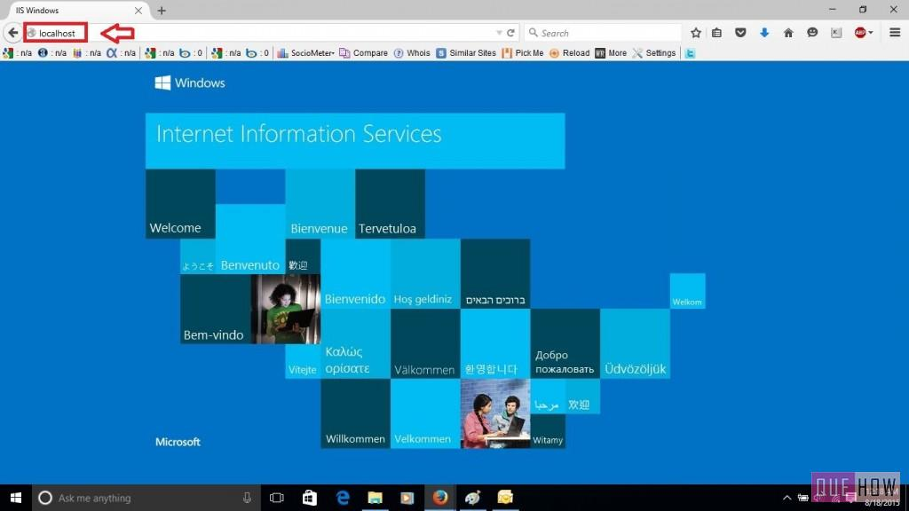](https://quehow.com/wp-content/uploads/2015/08/m1.jpg)

If you are getting some other screen instead of above screen means IIS is not installed on this machine. To install IIS on local machine, please proceed the below steps based on servers.

**IIS Configuration:**

**Windows 7 / 8 / 10:**

To install Internet Information Services (IIS) in Windows 7 / 8 / 10 machine, follow the steps below:

1. Start > Control Panel > Programs and Features

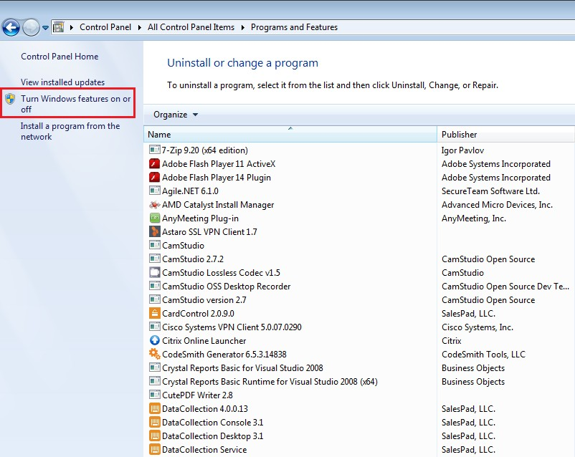

1. Click Turn Windows features on or off in left hand side. The Windows Features window will appear.
2. Make sure all features under Internet Information Services and Microsoft .NET Framework are selected.

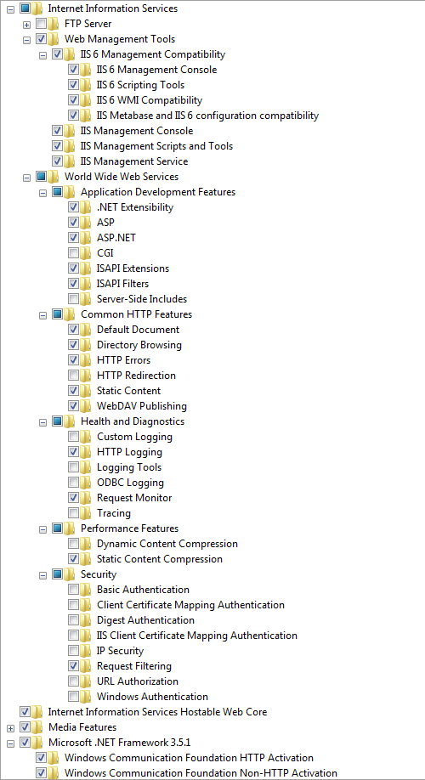

1. Click **OK**to install selected Windows components, including IIS.
2. Now open any browser which you want and then in the address bar of that browser, just type **“http://localhost”**.

You will see a web page as shown below

[](https://quehow.com/wp-content/uploads/2015/08/m1.jpg)

## **Windows Server 2008 / 2008 R2:**

This information provides a step by step walk through installing IIS 7.0 on Windows Server 2008.  
Ensure that you have administrative user rights on the computer on which you plan to install IIS 7. Note that by default, you do not have administrative user rights if you are logged on as a user other than as the built-in administrator, even if you were added to the local Administrators group on the computer (this is a new security feature in Windows Server 2008 called Local User Administrator).

Log on either to the built-in administrator account, or explicitly invoke applications as the built-in administrator by using the run as command-line tool.

**Note:** You can run runas /user:administrator cmd.exe so that every application you run from that command line will be elevated, eliminating the need to use the run as syntax from that command line.

If you are logged on to an account other than the built-in local administrator account, you may see the following security alert dialog box.  
  
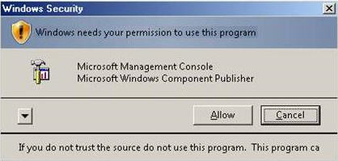  
**Start Server Manager:**

1. To start Server Manager, click **Start** > **All Programs** > **Administrative Tools** > **Server Manager**.  
     
   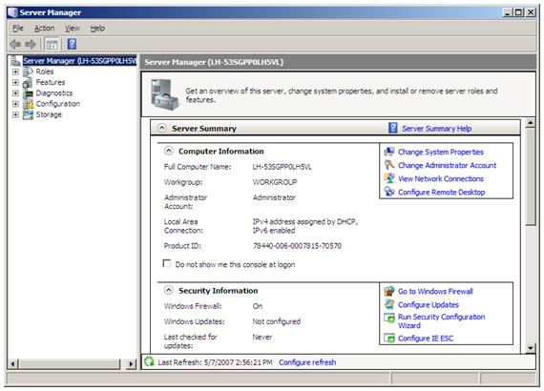
2. In the **Server Manager** window, scroll down to **Roles Summary**, and then click **Add Roles**. The **Add Roles Wizard** will start with a **Before You Begin** page. The wizard asks for verification of the following:
   * The administrator account has a strong password.
   * The network settings, such as IP addresses, are configured.
   * The latest security updates from Windows® Update are installed.
3. Select **Web Server (IIS)** on the **Select Server Roles** page. An introductory page will open with links for further information.

**Note:** When you use the **Add Roles Wizard to install** IIS, you get the default installation, which has a minimum set of role services. If you need additional IIS role services, such as **Application Development** or **Health and Diagnostics**, make sure to select the check boxes associated with those features in the **Select Role Services** page of the wizard.

1. Select the IIS services to be installed on the **Select Role Services** page. Add only the modules necessary. In this case, ASP.NET is selected, and a description of ASP.NET appears in the right pane. Once desired modules are added, click **next**.

## **Required IIS components need to be selected:**

The IIS components listed below satisfy the minimum requirements to run the Web Adaptor. If other IIS components are enabled, they do not need to be removed.

* Web Server
  + Common HTTP Features
    - Default Document
    - Static Content
  + Security
    - Request Filtering
    - Basic Authentication
    - Windows Authentication
  + Application Development
    - .NET Extensibility 4.5
    - .NET Extensibility
    - ASP.NET 4.5
    - ASP.NET
    - ISAPI Extensions
    - ISAPI Filters
* Management Tools
  + IIS Management Console
  + IIS 6 Management Compatibility
    - IIS 6 Metabase Compatibility
  + IIS Management Scripts and Tools
  + Management Service

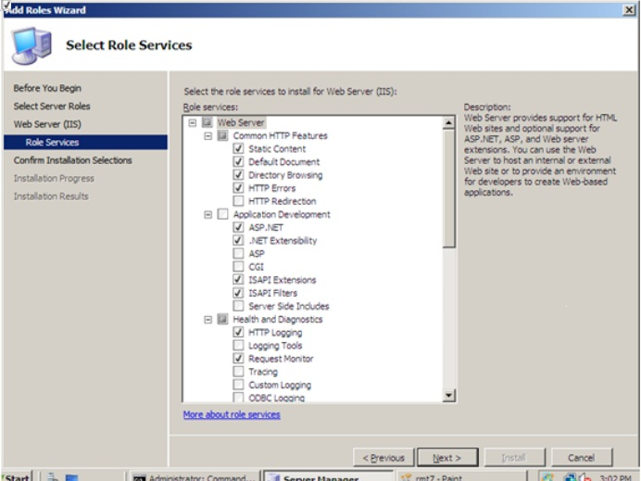

1. Add any required role services.

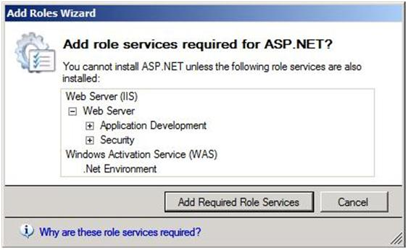

1. IIS is now installed with a default configuration for hosting ASP.NET on Windows Server. Click **Close** to complete the process.
2. Now open any browser which you want and then in the address bar of that browser, just type **“http://localhost”**.

You will see a web page as shown below otherwise you need to check above things once again.

[](https://quehow.com/wp-content/uploads/2015/08/m1.jpg)

**Windows Server 2012 / 2014 / 2016 Configuration:**

The following items are the minimum required items for Timecheck Setup kit to run and install properly on Windows Server 2012. To change these settings, open the Server Manager > Roles and verify Web Server (IIS) is installed. View the following details and ensure all of the following items are selected on the server.

To start Server Manager, click **Start** > **All Programs** > **Administrative Tools** > **Server Manager**.  
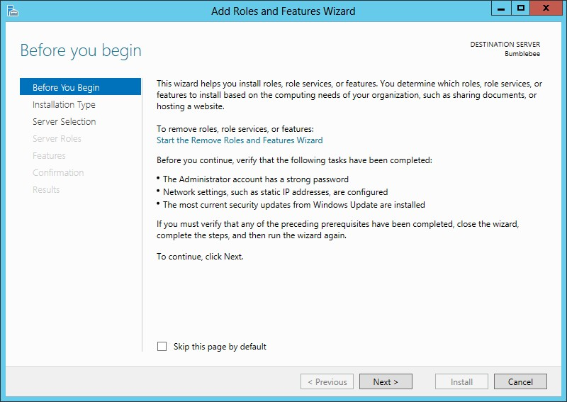

Select **Role-based or Feature-based Installation**:

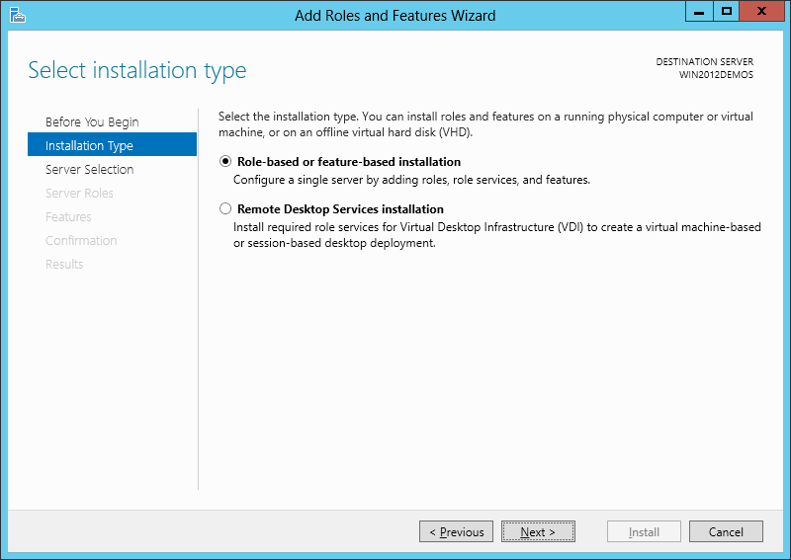

Select the appropriate server (local is selected by default), as shown below:

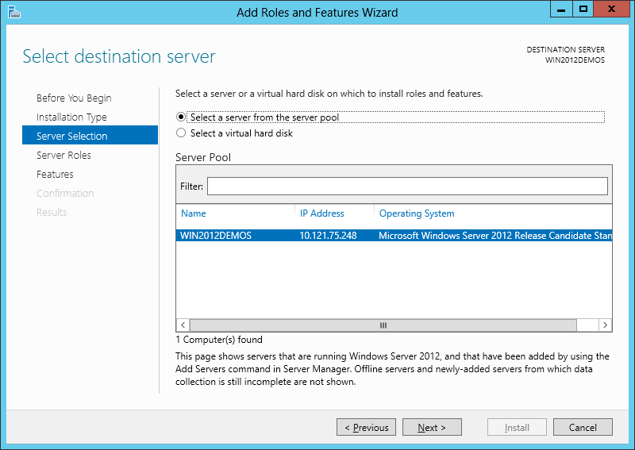**Required IIS components need to be selected:**

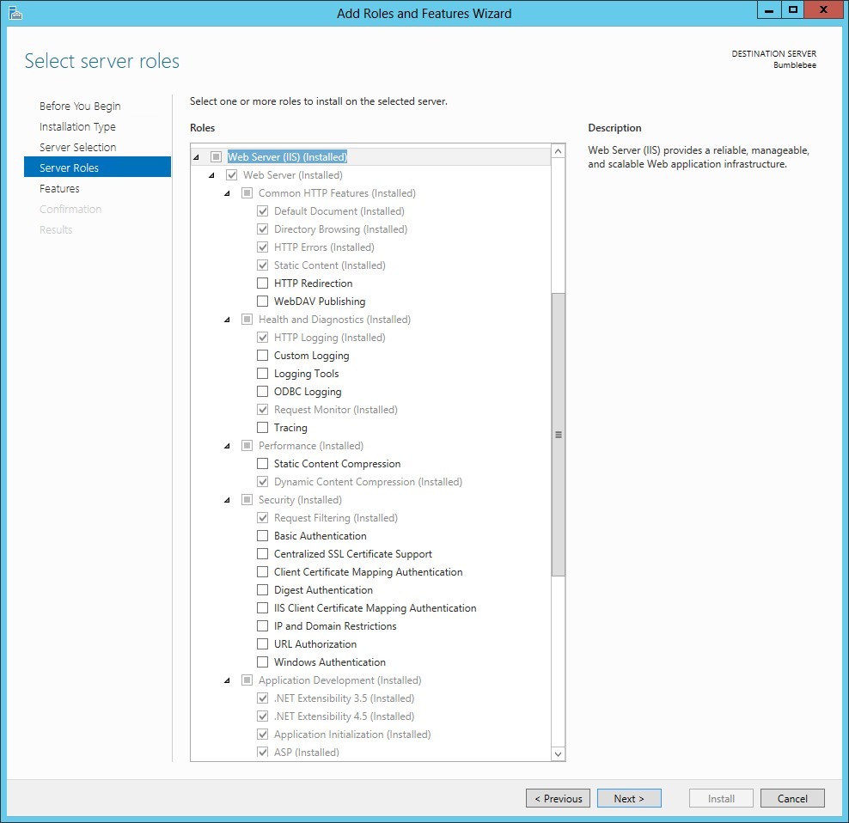

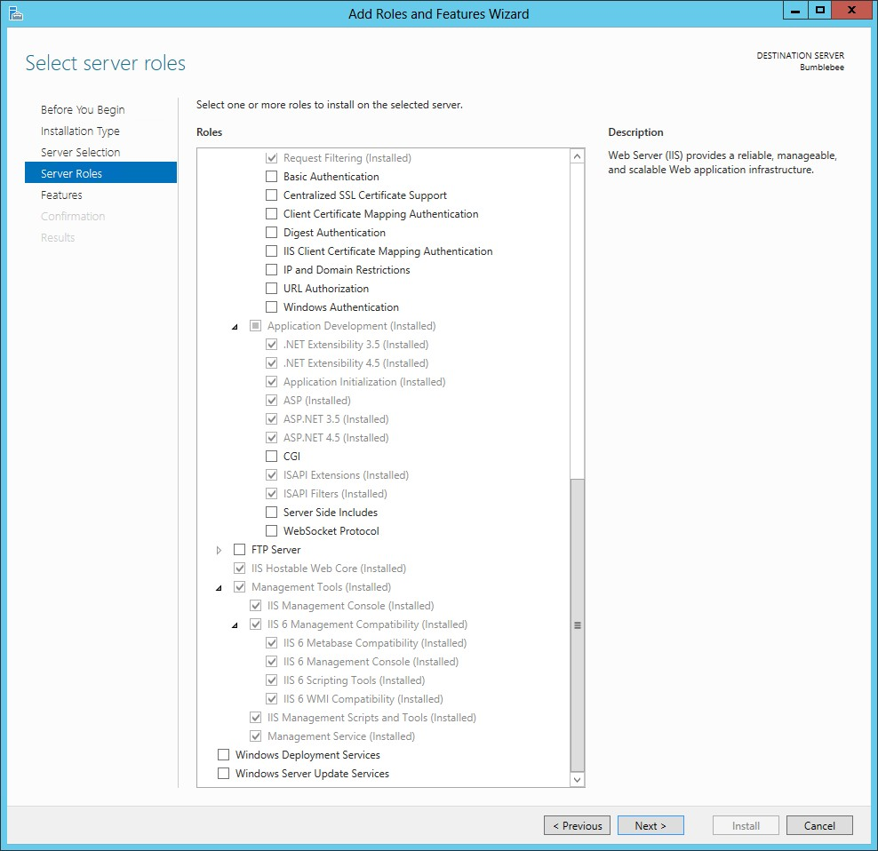

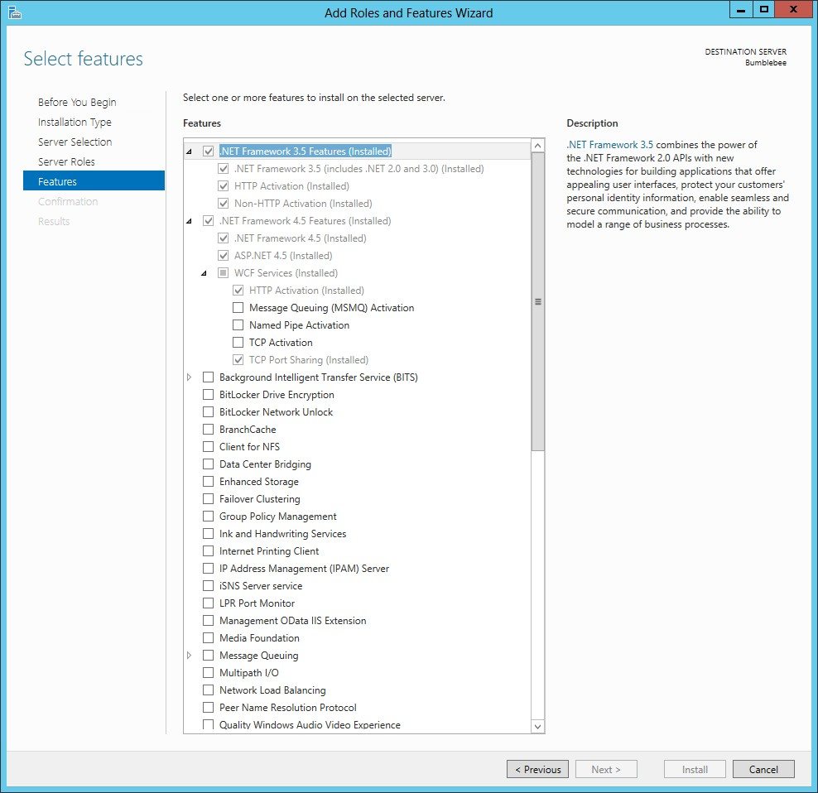

After you have selected all necessary roles and features, click the **Next**button to confirm your selection. Click the **Install**button to install selected roles and features on your server.

1. Now open any browser which you want and then in the address bar of that browser, just type **“http://localhost”**. If its installed successfully, You will see a below web page otherwise it will not see the screen.

[](https://quehow.com/wp-content/uploads/2015/08/m1.jpg)

*******************************End of IIS Installation*****************************

**Configuring IIS To Run 32-bit Applications On 64-bit Windows (IIS 6.0)**

**Note from Microsoft**:

Windows Server 2003TM, Service Pack 1 enables IIS 6.0 to run 32-bit Web applications on 64-bit Windows using the Windows-32-on-Windows-64 (WOW64) compatibility layer. IIS 6.0 using WOW64 is intended to run 32-bit personal productivity applications needed by software developers and administrators, including 32-bit Internet Information Services (IIS) Web applications.

To enable IIS 6.0 to run 32-bit applications on 64-bit Windows:

1. Click the Windows **Start**button. The Start menu/screen appears. Start typing internet information services manager in the search field and click the Internet Information Services (IIS) Manager once it appears.

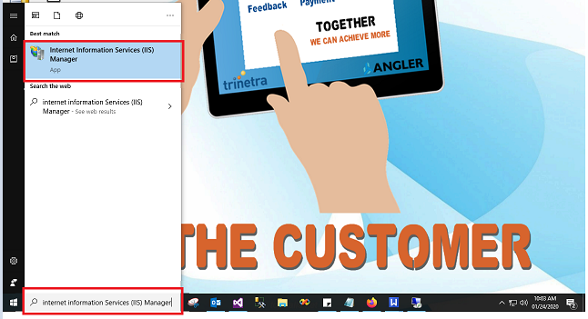

# Install and Set Up SQL

1. Install SQL.
   1. Choose New SQL Server stand-alone installation. 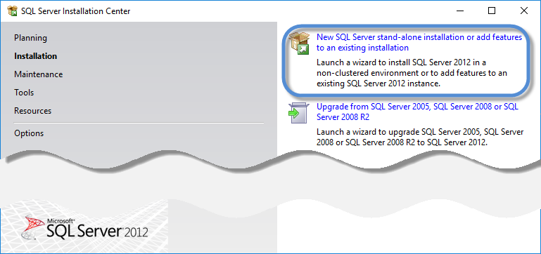
   2. Include any product updates.
   3. Accept the defaults in Feature Selection, Instance Configuration, and Server Configuration.
   4. In Database Engine Configuration, under Authentication Mode, choose Mixed Mode.

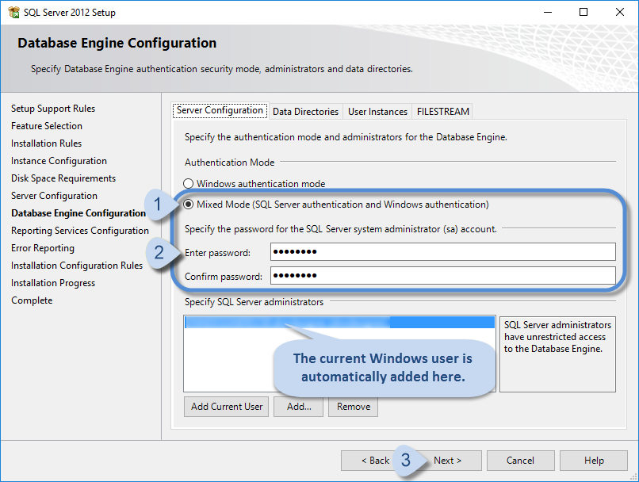

1. Accept the defaults in remaining dialogs.
2. Click Next button and Install the SQL server.

Installing Timecheck:

1. Click Timecheck.exe file in install kit folder of timecheck.
2. It will ask you to install Crystal report software, click ok.
3. After installation, it will open timecheck software for installation.
4. Click Next button.
5. It will load database configuration page for configuring the timecheck database.

Select / enter server name of sql server, Enter user id and password of selected server.

1. It will take few minutes for installation of timecheck software.
2. After successful installation of timecheck, it will open other setup kit automatically for installation. Please click next button alone here and install all the kit.
3. After the successful installation of all setup kit, it will open timecheck application in IE browser automatically.

**Troubleshoot:**

* If you got the below error while browse timecheck hosted url in browser, please install the kit which is available in the below path

<http://209.68.26.95/anglertechnologieseit/Timecheck/Ajaxkit.zip>

* After Installation, if you get the error message page,

please do the following

1. Go to Timecheck application hosted drive
2. Find and open web.config file in notepad
3. find the same value in the file and remove it whole value.
4. Now refresh the browser, it will open the timecheck application.

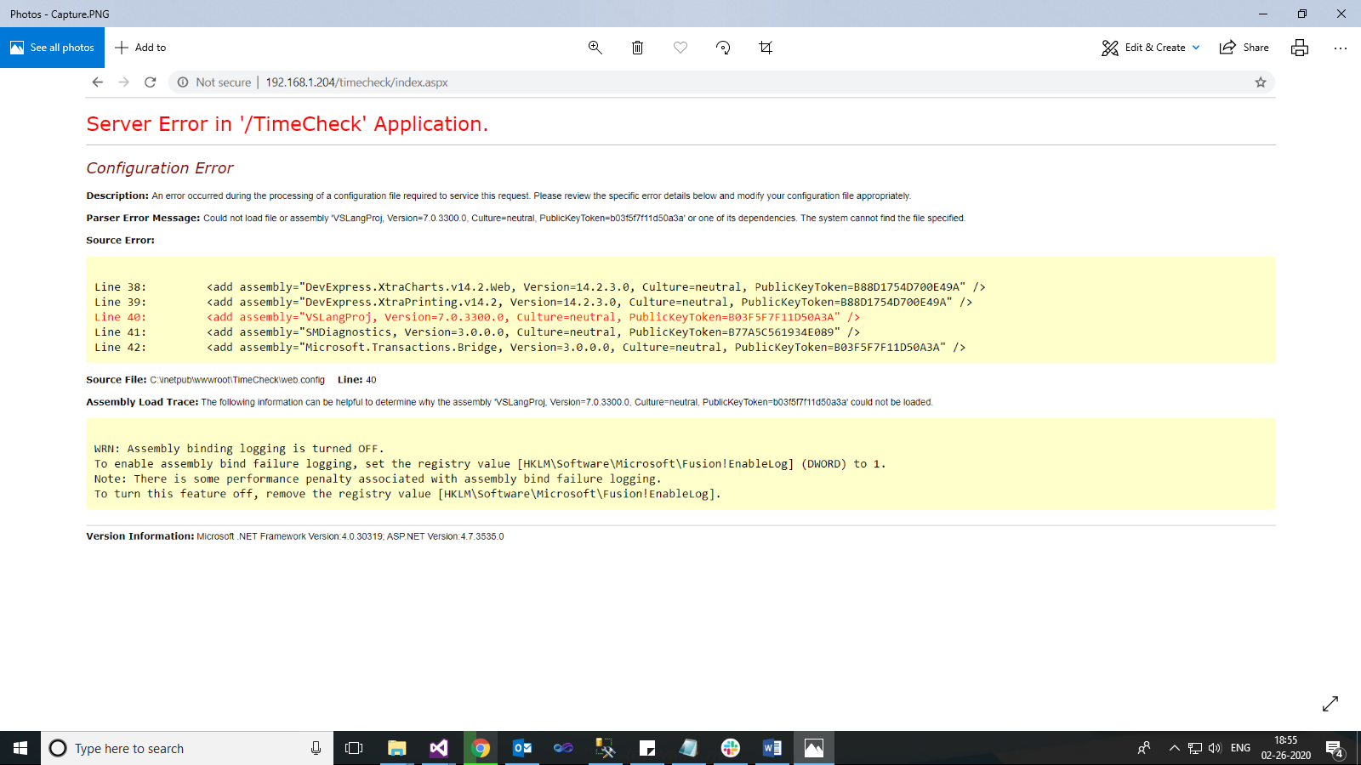

* If you got below error message while loading the timecheck application in browser, please proceed the below steps,

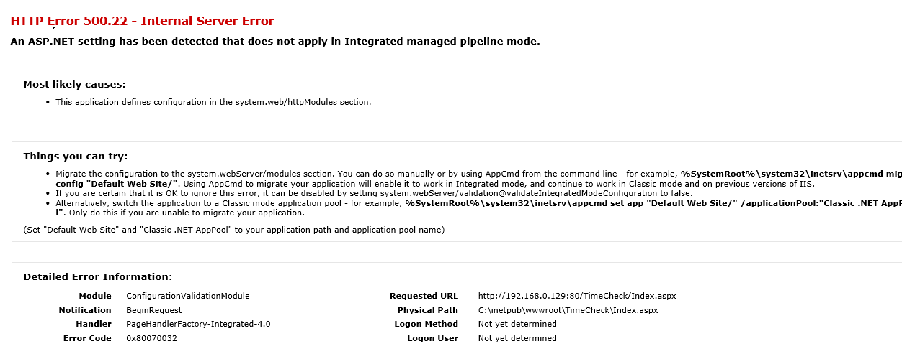

* 1. Open run command in timecheck installed machine.
  2. Type iis or inetmgr. It will open below window.



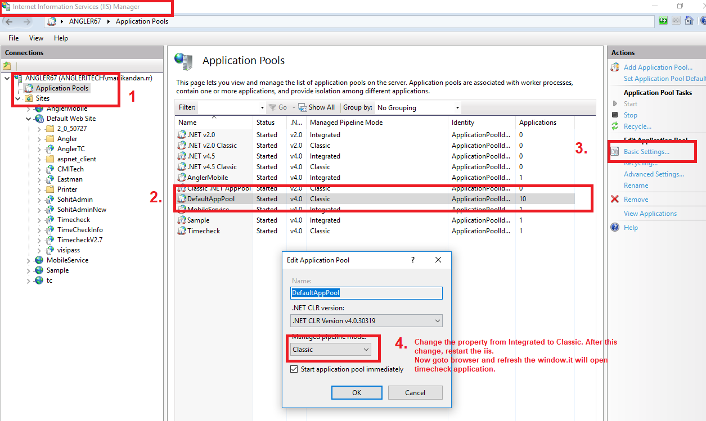

* 1. Select Application Pools option in left side first and then select DefaultAppPool in center window.
  2. Then Click Basic settings options, it will open Edit Application Pool window.
  3. Change Managed Pipeline mode to Classic from Integrated.
  4. Then restart the IIS.
  5. Now goto browser and access the timecheck application, it will open the timecheck.

1. While you click download template button in import master, if you got below alert message please do the below steps,

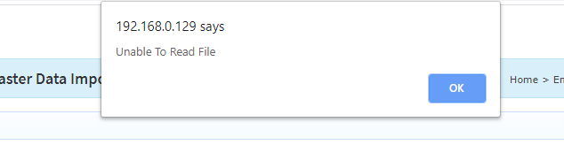

* 1. Open run command in timecheck installed machine.
  2. Type iis or inetmgr. It will open below window.



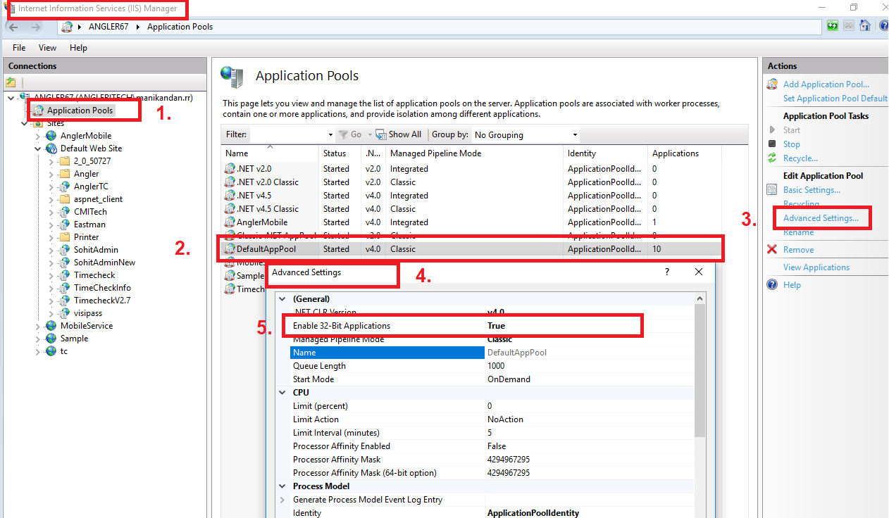

* 1. Select Application Pools option in left side first and then select DefaultAppPool in center window.
  2. Then Click Advanced settings option in right side window, it will open advanced settings window.
  3. Change the property Enable 32-Bit Applications to **True**.
  4. Then restart the IIS.
  5. Now go to browser and access the timecheck application and then try the import master right now.